Doctor Appointment scheduler
Name:K.Kaviarasan
Course:Dot Net
Project Guide:Yovan
S.NO | TOPICS | PAGE NO
1 | Introduction | 1.1
2 | Scope | 1.1
3 | Objectives | 1.1
4 | Modules/Features | 2.2
5 | Workflow/ER Diagram | 3.3
6 | Table Design | 4.5
7 | Time Duration | 5.6

1. Introduction
The Doctor Appointment Scheduler is a web-based system that simplifies and automates the process of booking appointments with doctors. Instead of patients waiting in hospitals or manually contacting doctors, the system provides an organized flow: view doctors, check availability through a calendar, book a slot, receive appointment confirmation, and reschedule or cancel if necessary. This ensures efficient hospital management and reduces waiting times for patients.

2. Scope
The scope of this project is to provide an end-to-end appointment scheduling solution for patients and doctors.
  - It covers doctor listing, specialization details, and availability.
  - Provides an interactive calendar for checking open slots.
  - Allows booking, confirmation, rescheduling, and cancellation of appointments.
  - Ensures no duplicate bookings and prevents schedule conflicts.
  - Can be extended to include SMS/Email notifications for confirmations.
  - Designed for hospitals, clinics, and healthcare centers to improve patient management.

3. Objectives
3.1 Provide a user-friendly appointment booking system for patients.
3.2 Maintain an up-to-date doctor list with specialization and availability.
3.3 Use a calendar system to display available and booked slots.
3.4 Enable patients to book, confirm, reschedule, or cancel appointments easily.
3.5 Prevent scheduling conflicts and reduce waiting times in hospitals.

4. Modules / Features
4.1 Modules:
4.1.1 Patient Module – Registration, login, booking, reschedule/cancel options.
4.1.2 Doctor Module – Profile management, availability updates, appointment list.
4.1.3 Admin Module – Manage doctors, patients, appointments, and reports.

  - Features:
    - Doctor List with specialization and contact details.
4.2.2 Calendar integration for availability and booked slots.
4.2.3 Slot booking with unique Appointment ID.
4. 2.4 Appointment confirmation page.
    - Reschedule and cancellation options.
4.2.6 Notifications (Email/SMS – optional).

5. Workflow / ER Diagram
Workflow:
Doctor List → Calendar → Book Slot → Appointment Confirmation → Reschedule/Cancel
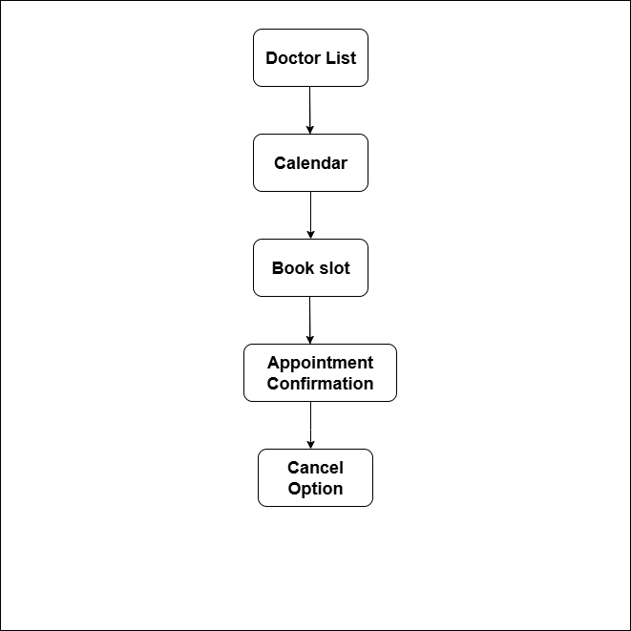

Column Name | Data Type | Length | Constraint | Description
countryId | UUID | N/A | PRIMARY KEY, DEFAULT gen_random_uuid() | Unique identifier for each record
countryName | VARCHAR | 100 | NOT NULL | Name of the country
isDeleted | BIT | N/A | DEFAULT FALSE | Soft delete flag (default is false)
6. Table Design

Column Name | Data Type | Length | Constraint | Description
maritalStatusId | UUID | N/A | PRIMARY KEY, DEFAULT gen_random_uuid() | Unique identifier for each record
maritalStatus | VARCHAR | 50 | NOT NULL | Marital status (e.g., Married, Single)
isDeleted | BIT | N/A | DEFAULT FALSE | Soft delete flag (default is false)

Column Name | Data Type | Length | Constraint | Description
relationshipId | UUID | N/A | PRIMARY KEY, DEFAULT gen_random_uuid() | Unique identifier for each record
relationshipName | VARCHAR | 50 | NOT NULL | Name of the relationship (e.g., Father, Mother)
isDeleted | BIT | N/A | DEFAULT FALSE | Soft delete flag (default is false)

Column Name | Data Type | Length | Constraint | Description
occupationId | UUID | N/A | PRIMARY KEY, DEFAULT gen_random_uuid() | Unique identifier for each record
occupationName | VARCHAR | 100 | NOT NULL | Name of the occupation (e.g., Engineer, Doctor)
isDeleted | BIT | N/A | DEFAULT FALSE | Soft delete flag (default is false)

Column Name | Data Type | Length | Constraint | Description
religionId | UUID | N/A | PRIMARY KEY, DEFAULT gen_random_uuid() | Unique identifier for each record
religionName | VARCHAR | 100 | NOT NULL | Name of the religion (e.g., Christianity, Islam)
isDeleted | BIT | N/A | DEFAULT FALSE | Soft delete flag (default is false)
Column Name | Data Type | Length | Constraint | Description
titleId | UUID | N/A | PRIMARY KEY, DEFAULT gen_random_uuid() | Unique identifier for each record
titleName | VARCHAR | 50 | NOT NULL | Name of the title (e.g., Mr., Mrs., Dr.)
isDeleted | BIT | N/A | DEFAULT FALSE | Soft delete flag (default is false)

7. Time Duration (4-Day Execution Plan)
Day 1 – Database & Setup
Create database tables (Users, Doctors, Appointments).
Connect SQL Server to .NET backend.
Day 2 – Backend APIs
Build APIs for Doctor List, Calendar availability, Book appointment, Confirm, Reschedule/Cancel.
Test APIs with Postman.
Day 3 – Frontend Development
Create web page for Doctor List.
Add Calendar selection for slots.
Create Booking form + Confirmation page.
Day 4 – Integration & Testing
Connect frontend with backend APIs.
Implement reschedule & cancel functionality.
Test full flow with demo data.
Prepare project documentation.

